Лаб.5 - Error correction #1 - Hamming Code

***Єлін Євген РІ-41 мн***

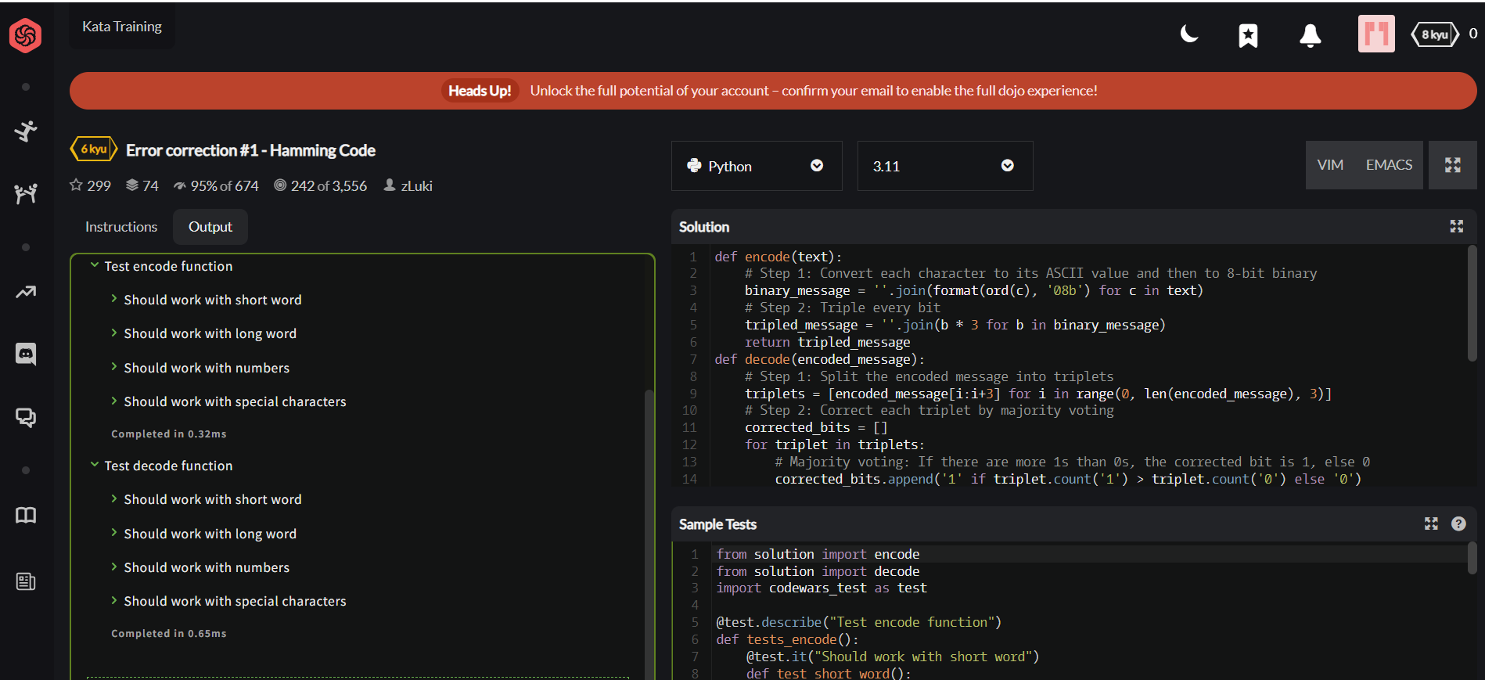

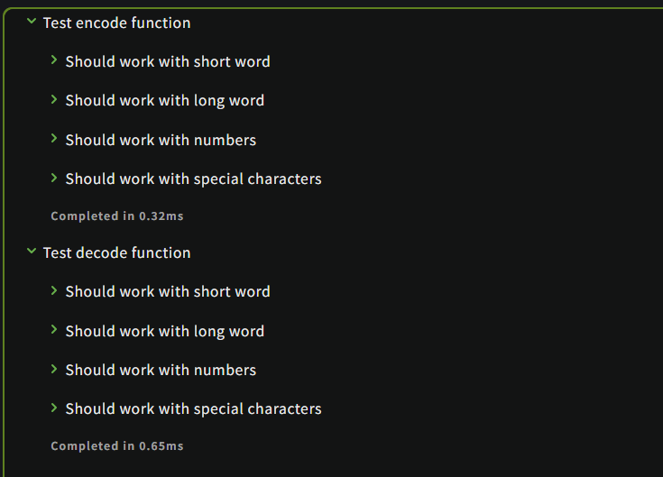

**Код програми на Python:**

def encode(text):

# Step 1: Convert each character to its ASCII value and then to 8-bit binary

binary_message = ''.join(format(ord(c), '08b') for c in text)

# Step 2: Triple every bit

tripled_message = ''.join(b * 3 for b in binary_message)

return tripled_message

def decode(encoded_message):

# Step 1: Split the encoded message into triplets

triplets = [encoded_message[i:i+3] for i in range(0, len(encoded_message), 3)]

# Step 2: Correct each triplet by majority voting

corrected_bits = []

for triplet in triplets:

# Majority voting: If there are more 1s than 0s, the corrected bit is 1, else 0

corrected_bits.append('1' if triplet.count('1') > triplet.count('0') else '0')

# Step 3: Group the corrected bits into 8-bit binary sequences

corrected_message = ''.join(corrected_bits)

# Step 4: Convert each 8-bit group back to an ASCII value

chars = []

for i in range(0, len(corrected_message), 8):

byte = corrected_message[i:i+8]

chars.append(chr(int(byte, 2))) # Convert the 8-bit binary to a character

# Step 5: Join the characters to form the final decoded string

return ''.join(chars)

# Example usage

encoded = encode("hey")

print("Encoded:", encoded)

decoded = decode(encoded)

print("Decoded:", decoded)